Addendum no: 1. (Note to all Suppliers)
Enquiry: E2918CXMWP

Provision of E-Learning Content Development Software subscription licenses for a period of five (5) years

Please note the following Clarifications Questions have been added:

- Clarifications questions from Suppliers and answers from Eskom:
- Q Supplier requested a Source File (Authoring Tool)
- A. Source File (Authoring Tool) Attached on Tender Bulletin

- Q. Supplier needed to be advised or direct them to where we can find the tender documents on the portal
- A. Eskom tenders - Eskom Tender Bulletin under (Current Tender Opportunities) search for Tender number: E2918CXMWP
See screenshot below:

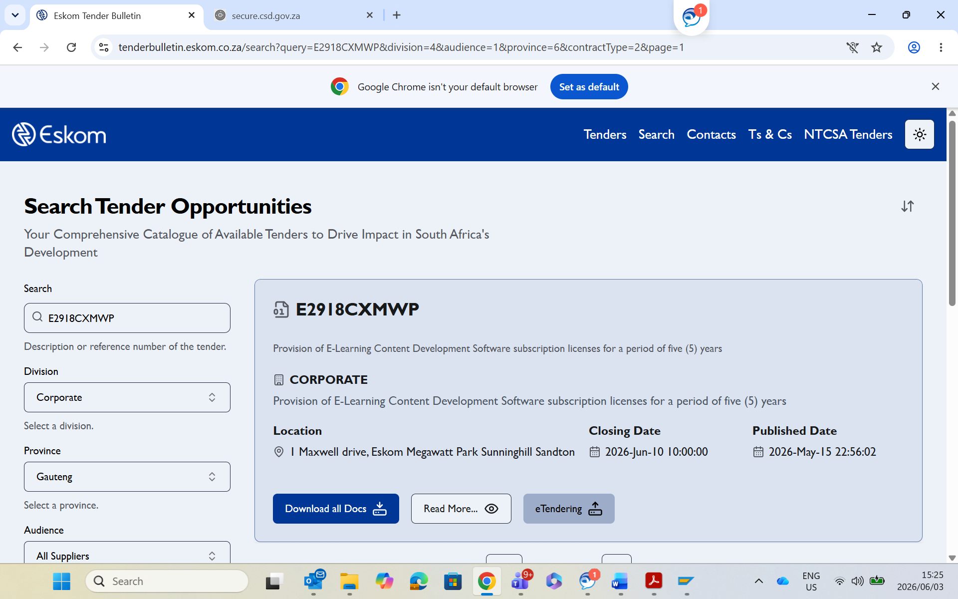
- Q. Supplier: The document but it does not have the scope of work, which is Annexure O on the Tender document
- Eskom: Scope of work was downloaded twice see screenshot below:
